MINUTES

Meeting: Planning Committee meeting
Date: 20th April 2026, 6.45pm.
Location: Thornwood Common Parish Hall, Weald Hall Lane, Thornwood

Councillors: (6) B Clegg (Chairman), A Buckley, T Blanks, S Hawkins, Spearman, Born

Officers in Attendance (2)
Susan De Luca – Clerk to the Council
Adriana Jones – Principal Finance Officer

Members of the Public (2)
Members of the Press (0)

P25.092 APOLOGIES FOR ABSENCE (3)
Councillors: A Tyler, A Irvine, P Lambert.

P25.093 OTHER ABSENCES (5)
Cllrs Stroud, S Jackman, MBE, P Etherington, Wood, Kinnear

P25.094 DECLARATIONS OF INTEREST
Cllr Spearman declared an interest in the Item in relation Larger Developments within the Local Plan – Happy Grow.

P25.095 CONFIRMATION OF MINUTES
The minutes of the previous Planning Committee meeting held on 23rd March 2026 were AGREED and signed as a true record.

P25.096 REPRESENTATIONS FROM MEMBERS OF THE PUBLIC
There was one representation from a Member of the public in relation to application EPF/0632/26.

P25.097
The following comments on Planning Applications were AGREED and NOTED
No | Application Number | Location | Proposal
1 | EPF/0585/26  Mohinder Bagry  (FPP) | 57, High Road,  North Weald Bassett,  CM16 6HW | Extension of existing office building, new external materials including roofing, wall cladding, doors and windows, revised parking area and external details, including EV charging point, landscaping, and biodiversity enhancement layout plan.
The Parish Council has NO OBJECTION to this Application, but there is a general concern that vehicles are reversing onto the High Road which is adjacent to a Pedestrian Crossing next to the site.
2 | EPF/0406/26  Caroline Brown  (HPP) | Upway Harlow Common, Hastingwood,  Harlow,  Essex, CM17 9NE | Proposed first and second floor loft conversion.
The Parish Council has No Objection to this Application
3 | EPF/0632/26  Yee Cheung  (FPP) | The Poplars,  Epping Road,  North Weald Bassett, Epping, CM16 6LA | Partial demolition of buildings on site. Erection of four new attached light industrial units with associated parking, and landscaping.
The Parish Council OBJECTS to this application. Whilst as a general principle the Parish Council supports the tidying up and improvement of this site (given the numerous unauthorised containers delivered to site in the past 18 months, along with the general mess and noise and disruption), there are a number of issues which have not been adequately addressed by this application as follows:

- Lack of clarity over use – the current permitted use on this site is B8 Storage and Distribution. The DAS states that there is ‘no intention of changing the usage of the offices which will remain, neither is there a plan to introduce new usage to the developed new units. In summary, the site is used for office, warehouse storage of parts, materials and equipment (e.g. tools).’ However, at various sections within the application it refers to the current use of the site being ‘light industrial’ and according to the application form Class E(c)(iii) ‘Other appropriate services in a commercial, business or service locality’. Clearly, this location is not a commercial, business or service locality, thus the use cannot (and is not) Class E(c)(iii). In addition, the application is not for a change of use in any case. It is absolutely vital that given the proximity of the site to both the SSSi and neighbouring properties, any change of use is given the correct scrutiny so it can be deemed appropriate. The site has been the subject of Enforcement issues for the past 18 months, with local residents frequently complaining (and providing video, audio and pictorial evidence) of mechanical work taking place on the site including welding, grinding, drilling, and general industrial noise. Clearly this is not B8 storage and distribution. This application does not provide the clarity necessary to establish the site use. This is also important to ensure the correct parking provision is provided.

- Access / Manoeuvring – The application sets out that HGVs visit the site for deliveries, and can occur daily in addition to numerous other commercial vans/vehicles. The application is not supported by a plan showing sweep path analysis to confirm that a HGV can access and exit the site safely, and that it involves no overrunning of footways/verges (especially given this proximity to Corporation of London land). The plans suggest that the two access points to the site are around 5m in width, however as a general rule safe access for HGVs should be between 5.5m and 6m. Is it absolutely essential that safe access for HGVs is considered, as without it the HGVs will park up on the extremely busy B181 (priority 2 road) creating a serious road safety risk. The ECC Highways response to this application sets out under proposed condition 1 that these matters should be addressed, HOWEVER this only relates to the construction period – not the lifetime of the proposed development. This needs to be addressed.

- Design / Parking – the application suggests that these four units are for industrial use, and for the use by the current occupant – TDK Mechanical Services. In addition, it states that they are expecting the business to grow, with 15 office based staff, and that these four individual units will be used by TDK for the ‘separate parts of the business’ to operate. It also states that TDK employ site-based engineers. However, the Parish Council cannot rationalise how the building of what is clearly four, separate business units, designed to be more aligned to warehouses rather than office use would fulfil their needs. In addition, having 12 parking spaces for 15 staff leaves the proposals short of parking spaces. There is a real concern that these units will actually be rented out to other business which would in turn result in a clear over-intensification and over development of the site. It makes absolutely no sense to build 4 separate units for one business. Furthermore, to have 12 parking spaces for 15 office staff, and then having various vans and engineer based vehicles on site leaves the site underequipped to deal with the proposed vehicles.

- Green Belt – Closely aligned with point 3 above, the buildings as currently presented represent and considerable increase in the built form of the site, impacting not only the adjacent SSSi, but the green belt. The Parish Council is not privy to the pre-application advice received by the applicant, and as such cannot substantiate that the planning officer deemed the altered roofline acceptable. At present, the proposal have a greater impact on the greenbelt than the current built form, and no special circumstances have been provided to justify this.

- Lighting – Under section 28 of the Wildlife and Countryside Act 1981, public authorities must take reasonable steps to avoid operations likely to damage an SSSI. This includes disturbance effects such as lighting. Artificial lighting must be assessed where it could affect the notified features of an SSSI, even if the development is outside the SSSI boundary, if there is the possibility of light spill, glare, and changes to dark corridors. The applicant has not provided any details regarding lighting, and given the proposed four units have glazed windows on both elevations, this issue must be addressed. Once again, lighting has been part of the ongoing enforcement issues (see image 1).

- Gates – the application does not propose any gates at the entrance points. Whilst this is ideal for ensuring no delayed access off the B181 Epping Road, this could possible present a security risk, specifically overnight, that the applicant may wish to consider.

- Building to be retained – there are no details provided as to the use of the retained building. The noise report suggests this is warehousing, and the location for where the forklift is stored. However, the supporting information states that these too are offices?

- Noise – The Parish Council supports the suggestion that the development would see the removal of the need for a skip lorry and the manual loading of scrap onto a flat bed truck as this has caused considerable disruption to local residents (as per the enforcement process currently being processed). However lorries, HGV, forklifts, vans, etc, are all noise, have noise ‘beeping’ sounds when reversing, and as such consideration should be given to the hours of operation of the site to ensure the amenity of local residents. As per point 1, it is also essential to clarify the use as this will affect the types of noise on the site.

- Permitted Development / Article 4 – Regardless of the outcome of this application, permitted development rights on the site should be removed given its direct adjacent proximity to the SSSi, and the neighbours opposite. This is necessary to ensure any future use of the site is correctly controlled.

- Corporation of London – at the time of writing this response, the EFDC Planning Portal did not show any response to the application from the Corporation of London. Given the proximity of the site, the Parish Council would like confirmation that the Corporation of London were directly consulted on this planning application. This is not publicly available on the EFDC website.

The Parish council confirms its intention to attend any planning committee meeting at EFDC at which this application will be considered.

Image 1

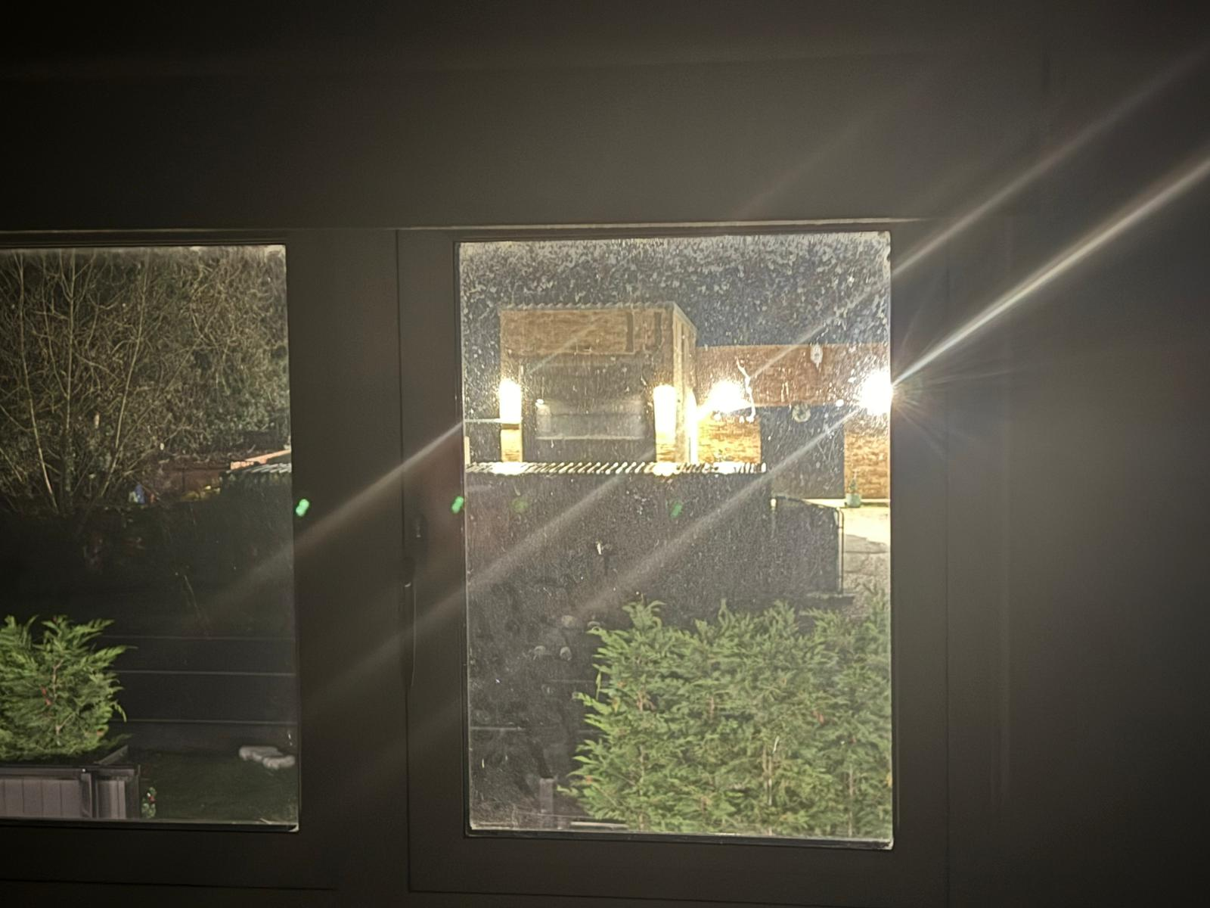

4 | EPF/0644/26  Yee Cheung | Hastingwood Farm, Hastingwood Road, Hastingwood,  Harlow, CM17 9JX | Change of use of garage building to form 2 no. Self-contained residential dwellings to include extension with associated private amenity areas, landscaping and car parking.
The Parish Council has No Objection to this Application

b) To CONSIDER any other urgent planning applications received since the agenda was compiled

No | Application Number | Location | Proposal
1 | EPF/0716/26  Sukhvinder Dhadwar | Tudor House,  High Road,  Thornwood,  Epping, CM16 6LT | Advertisement consent for non-illuminated totem sign.
The Parish Council Objects to the proposed advertising sign on the grounds that its scale and design is excessive, making it visually intrusive and wholly out of keeping with the surrounding area. The sign is also positioned in an inappropriate location, where it dominates the streetscape and detracts from the character of the development.
Granting this sign permanent, lifetime permission is unjustified. At most, it should be considered for temporary consent only, limited to the construction or sales period of this development.
Additionally, the sign poses a distraction to drivers, given its size and location close to the highway. This raises avoidable road-safety concerns.
For these reasons the Parish Council feel the application be refused or only granted-a temporary permission.
If this goes to a District Council Planning Committee the Parish Council would be willing to attend.

2 | EPF/0735/26  Suleman Uddin | 23, Cunningham Rise, North Weald Bassett, Epping, CM16 6JR | Removal of existing side outbuilding to allow for side extension and new entrance porch.
The Parish Council has NO OBJECTION to this Application

The following applications were NOTED:

No | Application Number | Location | Proposal
1 | EPF/0754/26  Frederique Caillat | Tudor Cottage,  Woodside,  Thornwood,  Epping, CM16 6LQ | Certificate of Lawful Development for proposed outbuilding.
NOTED

P25.098 DECISIONS BY EPPING FOREST DISTRICT COUNCIL
These were circulated on the .9th April

P25.099 EFDC LICENCES

a) Applications – none received.

b) Consultations – none received.

P25.100 PLANNING CORRESPONDENCE
- The Clerk advised Members of a communication she had received from Graham Courtney – Planning Services Manager at EFDC, who advised that Parish and Town Councils should ensure that all comments are sent to EFDC in relation to Planning at the initial comments stage as they will not be able to make any additional comments to a Planning Inspector at an Appeal..

- The Clerk has received notification of an appeal Against a Refusal following a decision made by Epping Forest District Council, details of which are as follows:
Site Address | Kilnash, Vicarage Lane, North Weald Bassett, Epping, CM16 6AL
Description | Demolition of dwelling and garage and construct a replacement dwelling (self-build).
PINS Appeal Reference | 6007030
Appellant | Mr and Mrs C and K Drewett
Start Date | 01/04/2026
Appeal Procedure | Written Representations

The Parish Council was consulted and raised no objection to this application, therefore No further comments.

P.25.101 ANY OTHER MATTERS RELATING TO PLANNING
To RECEIVE verbal updates in relation to other issues previously discussed if responses have been received.

Update on Larger Planning Applications within the Local Plan

a) NWB.R3 – Land south of Vicarage Lane, Application No. EPF/2587/23
The outline planning application was approved by EFDC’s Plans A Committee on the 8th April.

- Happy Grow – This should refer to Elmhurst which is the site adjacent to Happy Grow
The Clerk advised of a Zoom Meeting with Matt Concoran and proposed developers, and the Council PFO, in which she advised both the developers and Matt Concoran that if they wished to discuss any development on this site they would need to follow the agreed Parish Council Policy and present to the Developer Working Group.

P25.071 ANY OTHER MATTERS RELATING TO PLANNING
- Cllr Blanks advised Members on the following items:

EFDC Overview and Scrutiny Committee, 9 Homes on a Development at Fyfield purchased by EFDC for over £2 Million Pounds and 45 Homes soon to be purchased by EFDC from a development built by Qualis for £19 Million Pounds. Members Noted Cllr Blanks concern, some councillors advised they were aware of the situation in Fyfield but not of the other.

Meeting Closed 20.02

Signed ................................... Date ..............................................

