Local Authority Land


Part 2.2 (33) of the Transparency Code 2015 states that details of Local Authority Land should be published Annually. Paras 35-37 of the code are relevant.
35. Local authorities must publish details of all land and building assets including:
all service and office properties occupied or controlled by user bodies, both freehold and leasehold
- any properties occupied or run under Private Finance Initiative contracts
- all other properties they own or use, for example, hostels, laboratories, investment properties and depots
- garages unless rented as part of a housing tenancy agreement
- surplus, sublet or vacant properties
- undeveloped land
- serviced or temporary offices where contractual or actual occupation exceeds three months, and
- all future commitments, for example under an agreement for lease, from when the contractual commitment is made.
Information about the following land and building assets are to be excluded from publication:
- rent free properties provided by traders (such as information booths in public places or ports)
- operational railways and canals
- operational public highways (but any adjoining land not subject to public rights should be included)
- assets of national security, and
- information deemed inappropriate for public access as a result of data protection and/or disclosure controls (eg. such as refuge houses).

36. For the purposes of this dataset about local authority land (paragraphs 35 to 37), details about social housing should not be published. However, information about the value of social housing stock contained in a local authority’s Housing Revenue Account does need to be published for the social housing asset value dataset (paragraphs 38 to 41).
37. For each land or building asset, the following information must be published together in one place:
- Unique Property Reference Number29
- Unique asset identity - the local reference identifier used by the local body, sometimes known as local name or building block. There should be one entry per asset or user/owner (eg. on one site there could be several buildings or in one building there could be several users floors/rooms etc – where this is the case, each of these will have a separate asset identity). This must include the original reference number from the data source plus authority code
- name of the building/land or both
- street number or numbers - any sets of 2 or more numbers should be separated with the ‘-‘ symbol (eg. 10-15 London Road)
- street name – this is the postal road address30
- post town
- United Kingdom postcode
- map reference – local authorities may use either Ordnance Survey or ISO 6709 systems to identify the location of an asset, but must make clear which is being used. Where an Ordnance Survey mapping system is used (the grid system) then assets will be identified using Eastings before Northings. Where geocoding in accordance with ISO 6709 is being used to identify the centre point of the asset location then that reference must indicate its ISO coordinates
- whether the local authority owns the freehold or a lease for the asset and for whichever category applies, the local authority must list all the characteristics that apply from the options given below:

for freehold assets:
- occupied by the local authority
- ground leasehold
- leasehold
- licence
- vacant (for vacant properties, local authorities should not publish the map reference or full address details, they should only publish the first part of the postcode31).

For leasehold assets:
o occupied by the local authority
o ground leasehold
o sub leasehold
o licence.

for other assets:
o free text description eg. rights of way, access etc32.

- whether or not the asset is land only (i.e. without permanent buildings) or it is land with a permanent building.

* UPRN - Unique Property Reference Number is a unique 12 digit number assigned to every unit of land and property recorded by local government - this is a statutory obligation. The UPRN uniquely and definitively identified every addressable location in the Country.
Name of building/Land | Weald Common, North Weald Bassett | Address | Just off the High Road in North Weald, past the North Weald Village Hall, North Weald, Essex  Nearest Postcode CM16 6BU
Ownership | Owned by the Parish Council for the benefit of the local community | Map Reference | N 51°42'47.77" E 0°10'04.70"
UPRN* | Not an addressable location | Land or Building | Land only
Unique Asset Identity | N/A | Notes

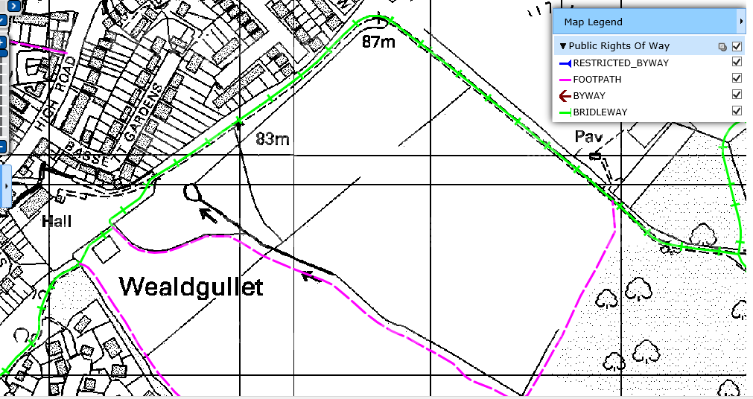
KEY
= Ownership of land

Name of building/Land | Bluemans End Recreation Ground, North Weald Bassett | Address | Down a small pathway just off bluemans End, North Weald Bassett, Essex  Nearest Post code CM16 6HD
Ownership | Owned by Epping Forest District Council, and leased to North Weald Bassett Parish Council | Map Reference | N 51°43'39.76" E 0°10'55.01"
UPRN* | Not an addressable location | Land or Building | Land only
Unique Asset Identity | N/A | Notes

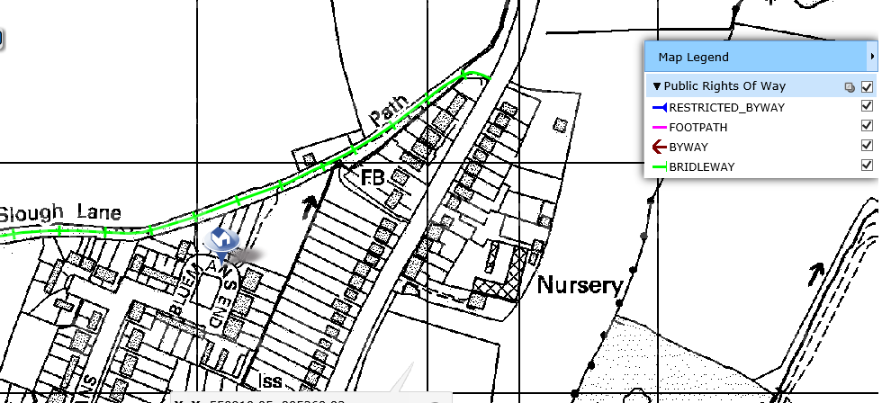
KEY
= Extent of leased land
Name of building/Land | North Weald Cemetery, North Weald | Address | Vicarage Lane West, North Weald Essex  Nearest Post code CM16 6AL
Ownership | Owned by North Weald Bassett Parish Council | Map Reference | N 51°43'32.61" E 0°09'42.07"
UPRN* | Not an addressable location | Land or Building | Land only
Unique Asset Identity | N/A | Notes

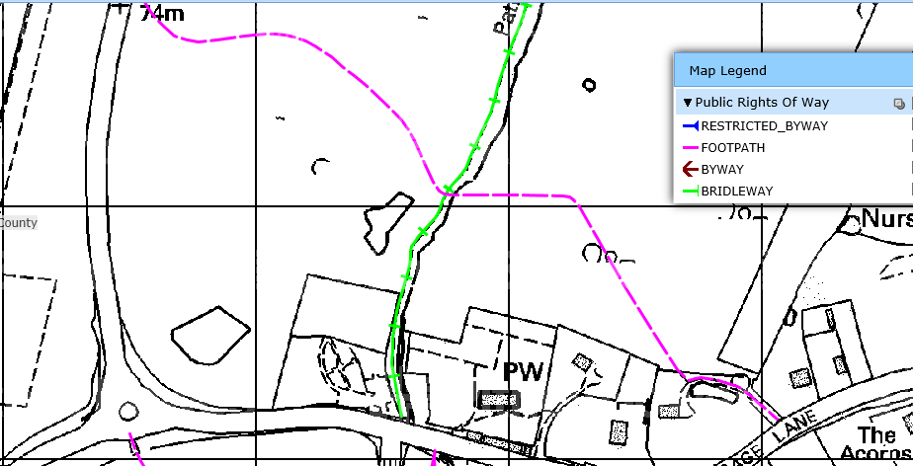
KEY
= Extent of ownership

Name of building/Land | Hastingwood Allotments A, Hastingwood | Address | Hastingwood Road, Hastingwood, Essex  Nearest Postcode CM17 9JS
Ownership | Owned by North Weald Bassett Parish Council | Map Reference | N 51°44'38.38" E 0°08'32.18"
UPRN* | Not an addressable location | Land or Building | Land only
Unique Asset Identity | N/A | Notes

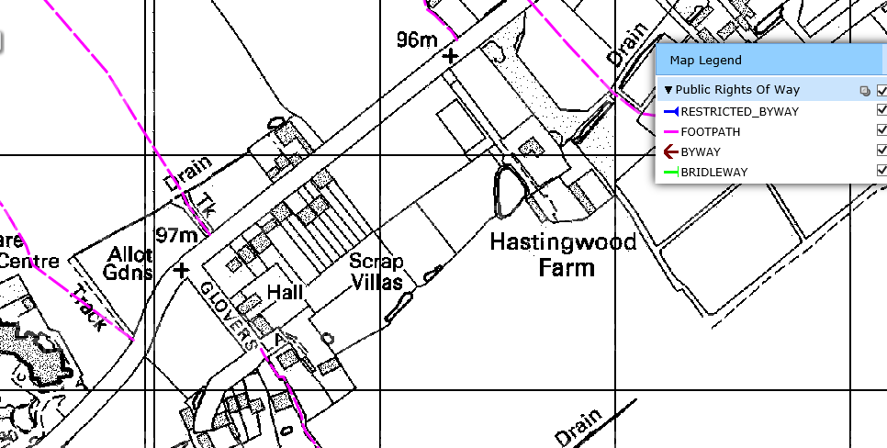
KEY
= Extent of ownership

KEY
= Areas to be checked
Name of building/Land | Hastingwood Allotments B, Hastingwood | Address | Hastingwood Road, Hastingwood, Essex  Nearest Postcode CM17 9JS
Ownership | Owned by North Weald Bassett Parish Council | Map Reference | N 51°44'40.16" E 0°08'35.96"
UPRN* | Not an addressable location | Land or Building | Land only
Unique Asset Identity | N/A | Notes

KEY
= Extent of ownership

KEY
= Areas to be checked
Name of building/Land | Parish Hall, Thornwood Common | Address | Weald Hall Lane, Thornwood, Essex  Nearest Postcode CM16 6NB
Ownership | Owned by North Weald Bassett Parish Council | Map Reference | N 51°43'18.20" E 0°07'48.48"
UPRN* | Not an addressable location | Land or Building | Land with permanent buildings
Unique Asset Identity | N/A | Notes | Village Hall, managed by Local Authority.

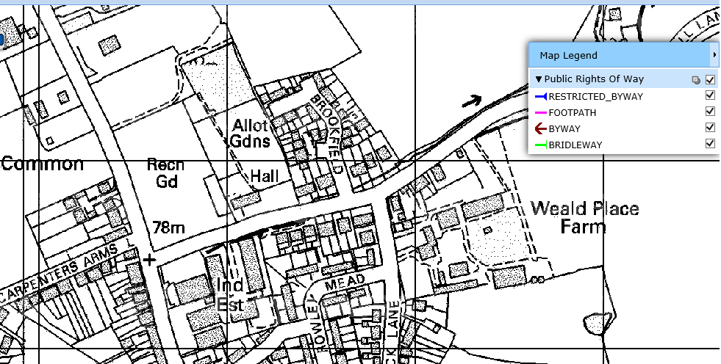
KEY
= Extent of ownership

Name of building/Land | Thornwood Common, Thornwood | Address | Weald Hall Lane, Thornwood, Essex  Nearest Postcode CM16 6NB
Ownership | Owned by North Weald Bassett Parish Council | Map Reference | N 51°43'18.49" E 0°07'45.20"
UPRN* | Not an addressable location | Land or Building | Land only
Unique Asset Identity | N/A | Notes

KEY
= Extent of ownership

Name of building/Land | Thornwood Nature Reserve, Thornwood | Address | Weald Hall Lane, Thornwood, Essex  Nearest Postcode CM16 6NB
Ownership | Owned by North Weald Bassett Parish Council | Map Reference | N 51°43'22.09" E 0°07'47.28"
UPRN* | Not an addressable location | Land or Building | Land only
Unique Asset Identity | N/A | Notes | Nature Reserve

KEY
= Extent of ownership

Name of building/Land | Thornwood Allotments, Thornwood | Address | Weald Hall Lane, Thornwood, Essex  Nearest Postcode CM16 6NB
Ownership | Owned by North Weald Bassett Parish Council | Map Reference | N 51°43'20.46" E 0°07'48.77"
UPRN* | Not an addressable location | Land or Building | Land only
Unique Asset Identity | N/A | Notes | Allotments

KEY
= Extent of ownership

KEY
= Areas to be checked
Name of building/Land | Village Green, North Weald | Address | High Road, North Weald, Essex  Nearest Postcode CM16 6BZ
Ownership | Owned by Essex County Council, leased to North Weald Bassett Parish Council for a peppercorn rent | Map Reference | N 51°43'00.73" E 0°07'48.77"
UPRN* | Not an addressable location | Land or Building | Land only
Unique Asset Identity | N/A | Notes

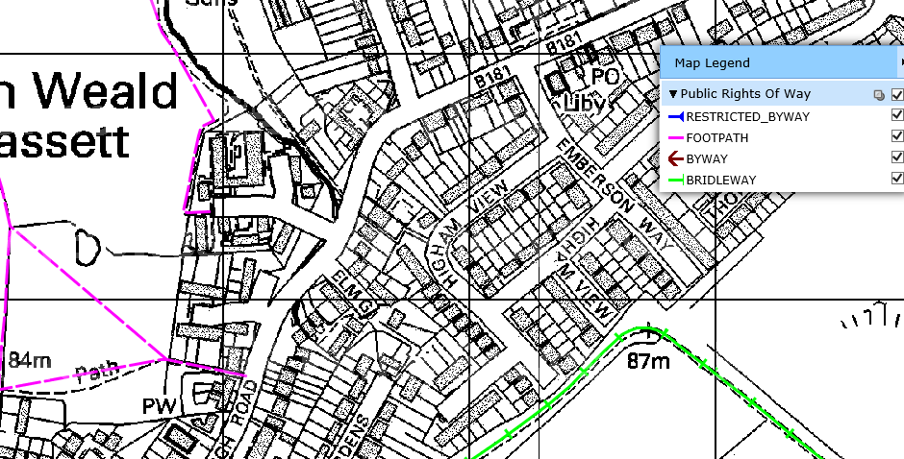
KEY
= Extent of ownership

Name of building/Land | Pike Way, North Weald | Address | Pike Way, North Weald, Essex  Nearest Postcode CM16 6BL
Ownership | Owned by Epping Forest District Council, and leased by North Weald Bassett Parish Council | Map Reference | N 51°42'43.93" E 0°09'29.69"
UPRN* | Not an addressable location | Land or Building | Land only
Unique Asset Identity | N/A | Notes

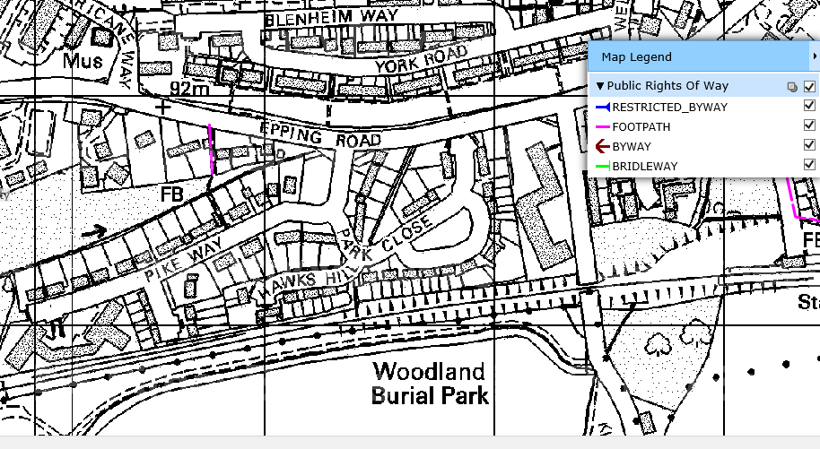
KEY
= Extent of ownership
Name of building/Land | Wheelers Farm Gardens Allotments, North Weald | Address | Off High Road, North Weald, Essex  Nearest Postcode CM16 6BZ
Ownership | Owned by North Weald Bassett Parish Council | Map Reference | N 51°43'05.97" E 0°09'59.46"
UPRN* | Not an addressable location | Land or Building | Land only
Unique Asset Identity | N/A | Notes | Allotment

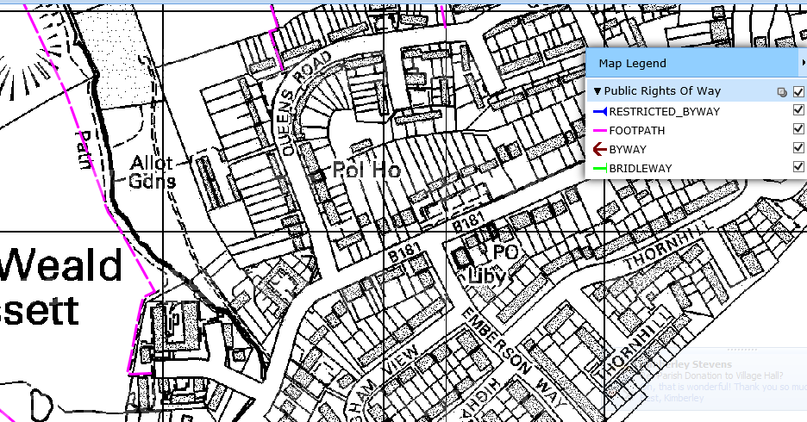
KEY
= Extent of ownership
KEY
= Areas to be checked
Map N1 - Wheelers Farm Gardens Allotments, North Weald

Name of building/Land | Queens Road Allotments, North Weald | Address | Queens Road, North Weald, Essex  Nearest Postcode CM16 6JE
Ownership | Owned by Epping Forest District Council, and leased by North Weald Bassett Parish Council | Map Reference | N 51°43'09.18" E 0°10'00.59"
UPRN* | Not an addressable location | Land or Building | Land only
Unique Asset Identity | N/A | Notes | Allotments

KEY
= Extent of ownership

Name of building/Land | Old Bowls Club, Weald Common, North Weald Bassett | Address | Off the North Weald High Road, past the village hall, and accessed via using the private road owned by Peer Group
Ownership | Owned by the Parish Council for the benefit of the local community | Map Reference | N 51°42'52.48" E 0°10'29.72"
UPRN* | Not an addressable location | Land or Building | Land only
Unique Asset Identity | N/A | Notes | Acquired 2025

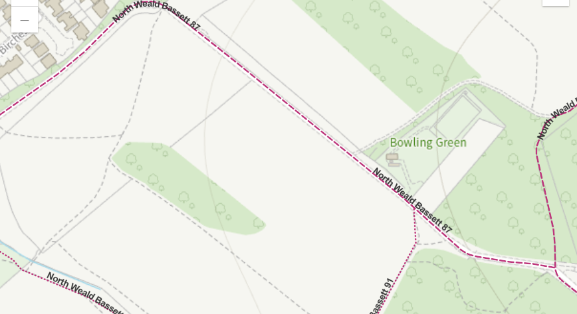
KEY
= Extent of ownership

North Weald Bassett Parish Council - Parking Spaces
The Parish Council owns 8 car parking spaces located near North Weald Village Hall in the centre of North Weald Village.
Planning permission for 10 spaces was obtained under EPF/1241/01 (see map A), however the Parish Council only own 8 of these spaces (see map B). These are spaces for public parking for the use and enjoyment of Weald Common only, and are not chargeable. They are not general public parking spaces.
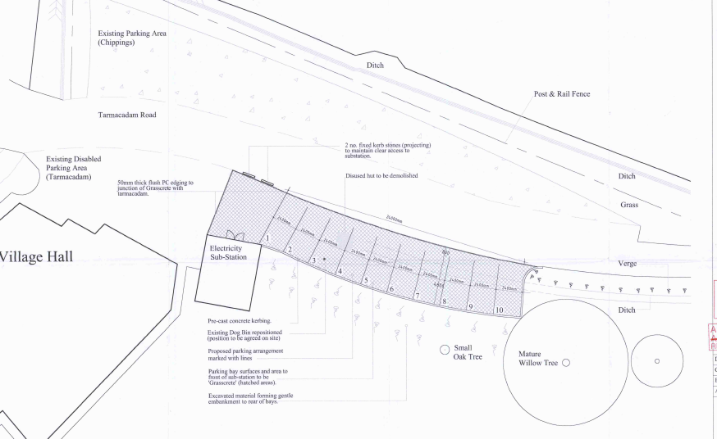
PLAN A
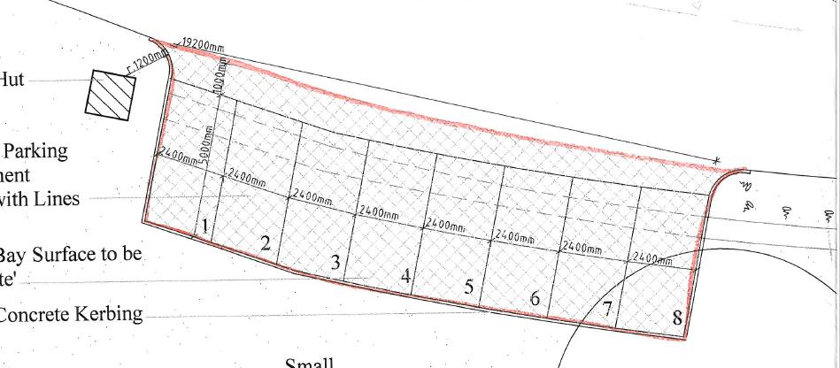
PLAN B

